
PSG Institute of Technology And Applied Research Neelambur, Coimbatore - 641062
ECO CLUB
TREE PLANTATION DRIVE REPORT
Event Title Event Category Date & Duration Co-ordinator Resource Person Venue
No. of Participants

No. of Saplings Planted
Club Activity

Dr. A. Kumaravel, ASP/Chemistry Kurumbapalayam Village

The Eco Club organized a Tree Plantation Drive on 05 June 2026 at 12.00 PM in
Kurumbapalayam Village, in observance of World Environment Day.
The event aimed to promote environmental awareness and sustainable practices among students. Preparations, including site inspection and pit digging, were completed a day prior.
Students were guided on proper planting techniques and handling of saplings. A total of 60 saplings were successfully planted.
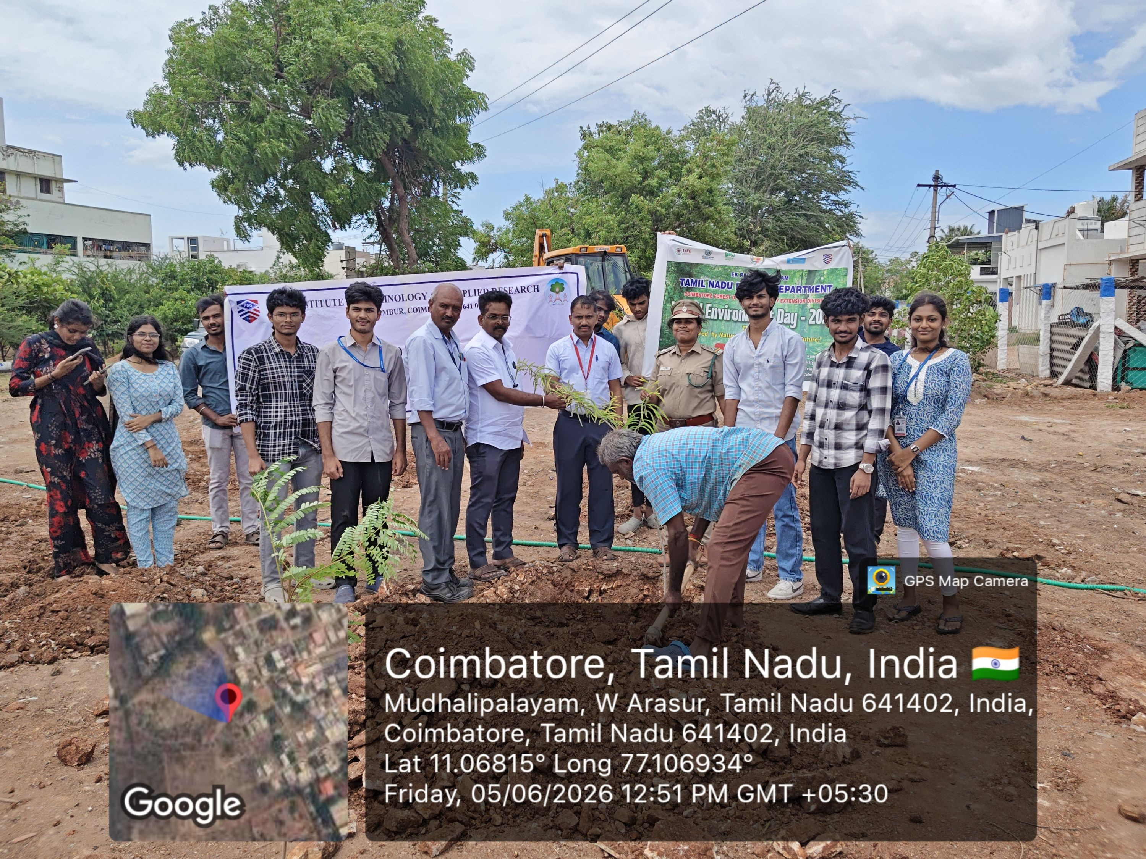
Around 20 students actively participated under the guidance of Dr. A. Kumaravel & 5 forest officers. The event concluded with a vote of thanks, encouraging continued involvement in eco-friendly activities.

Students and faculty during the World Environment Day, tree plantation drive at Kurumbapalayam Village, standing
with newly planted saplings.

